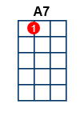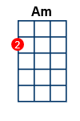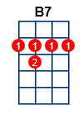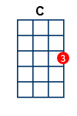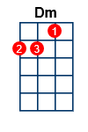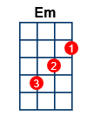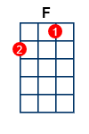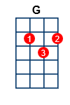

Can't Help Falling In Love With You [3/4]

[C] Wise [Em] men [Am] say.
[Am] . only [F] fools [C] rush [G] in
[G] . But [F] I [G] can't [Am] help
[F] falling in [C] love [G] with [C] you . [C] . .
[C] Shall [Em] I [Am] stay,
[Am] . would it [F] be [C] a [G] sin?
[G] . If [F] I [G] can't [Am] help
[F] falling in [C] love [G] with [C] you . [C] . .
[Em] Like a river [B7] flows [Em] surely to the [B7] sea
[Em] Darling so it [B7] goes
[Em] Some things [A7] are meant to [Dm] be [G]
[C] Take [Em] my [Am] hand,
[Am] . take my [F] whole [C] life [G] too
[G] . For [F] I [G] can't [Am] help
[F] falling in [C] love [G] with [C] you . [C] . .
[Em] Like a river [B7] flows [Em] surely to the [B7] sea [Em] Darling so it [B7] goes
[Em] Some things [A7] are meant to [Dm] be [G]
[C] Take [Em] my [Am] hand,
[Am] . take my [F] whole [C] life [G] too
[G] . For [F] I [G] can't [Am] help
[F] falling in [C] love [G] with [C] you . [C] . .
[G] . For [F] I [G] can't [Am] help
[F] falling in [C] love [G] with [C] you . [C] . .

